1. A)

|  |  |  |  |
| --- | --- | --- | --- |
| Table 1 | | | |
| Year | Project 1 cash flow ($) | Discount Factor @ 7% | Discounted Cash Flow |
| 0 | -100,000 | 1.0000 | -100,000 |
| 1 | 10,000 | 0.9346 | 9,345.7944 |
| 2 | 10,000 | 0.8734 | 8,734.3873 |
| 3 | 10,000 | 0.8163 | 8,162.9788 |
| 4 | 20,000 | 0.7629 | 15,257.9042 |
| 5 | 100,000 | 0.7130 | 71,298.6179 |
| Net Profit | 50,000 |  | NPV = 12,799.6826 |

|  |  |  |  |
| --- | --- | --- | --- |
| Table 2 | | | |
| Year | Project 2 cash flow ($) | Discount Factor @ 7% | Discounted Cash Flow |
| 0 | -100,000 | 1.0000 | -100,000 |
| 1 | 30,000 | 0.9346 | 28,037.3832 |
| 2 | 30,000 | 0.8734 | 26,203.1618 |
| 3 | 30,000 | 0.8163 | 24,488.9363 |
| 4 | 30,000 | 0.7629 | 22,886.8564 |
| 5 | 30,000 | 0.7130 | 21,389.5854 |
| Net Profit | 50,000 |  | NPV = 23,005.9231 |

b) Project 1: NPV = $12,799.68 Payback Period: 4.5 years

Project 2: NPV = $23,005.92 Payback Period: 3.33 years

c) ROI for both projects are 10%.

d) The ROI are the same for both projects so that won’t influence our decision. Project 2 has a higher NPV and a shorter payback period than Project 1, so I will pick Project 2 for both factors.

a.

|  |  |  |  |  |
| --- | --- | --- | --- | --- |
| Equipment | P1 | P2 | P3 | Average Payoff |
| C1 | 70 | 80 | 90 | (70 + 80 + 90) / 3 = 80 |
| C2 | 100 | 20 | 120 | (100 + 20 + 120) / 3 = 80 |
| C3 | 100 | 90 | 60 | (100 + 90 + 60) / 3 = 83.33 |
| C4 | 30 | 30 | 140 | (30 + 30 + 140) / 3 = 66.67 |

Equipment C3 would be purchased because it has the highest average payoff

b.

|  |  |  |  |  |
| --- | --- | --- | --- | --- |
| Equipment | P1 | P2 | P3 | Worst Payoff |
| C1 | 70 | 80 | 90 | 70 |
| C2 | 100 | 20 | 120 | 20 |
| C3 | 100 | 90 | 60 | 60 |
| C4 | 30 | 30 | 140 | 30 |

Equipment C1 would be purchased because it has the highest worst payoff

c.

|  |  |  |  |  |
| --- | --- | --- | --- | --- |
| Equipment | P1 | P2 | P3 | Best Payoff |
| C1 | 70 | 80 | 90 | 90 |
| C2 | 100 | 20 | 120 | 120 |
| C3 | 100 | 90 | 60 | 100 |
| C4 | 30 | 30 | 140 | 140 |

Equipment C4 would be purchased because it has the highest best payoff

d.

|  |  |  |  |  |
| --- | --- | --- | --- | --- |
| Equipment | Best Payoff | Worst Payoff | α = 0.2 | Blended Payoff |
| C1 | 90 | 70 | (0.2 * 90) + (0.8 * 70) | 74 |
| C2 | 120 | 20 | (0.2 * 120) + (0.8 * 20) | 40 |
| C3 | 100 | 60 | (0.2 * 100) + (0.8 * 60) | 68 |
| C4 | 140 | 30 | (0.2 * 140) + (0.8 * 30) | 52 |

Equipment C1 would be purchased because it has the highest blended payoff

e.

|  |  |  |  |  |
| --- | --- | --- | --- | --- |
| Equipment | P1 | P2 | P3 | Maximum Regret |
| C1 | 100 – 70 = 30 | 90 – 80 = 10 | 140 – 90 = 50 | 50 |
| C2 | 100 – 100 = 0 | 90 – 20 = 70 | 140 – 120 = 20 | 70 |
| C3 | 100 – 100 = 0 | 90 – 90 = 0 | 140 – 60 = 80 | 80 |
| C4 | 100 – 30 = 70 | 90 – 30 = 60 | 140 – 140 = 0 | 70 |

Equipment C1 would be purchased because it has the lowest maximum regret

|  |  |  |
| --- | --- | --- |
| Optimum Points | | |
| Routine | Execution Time (ms) | Number of Records |
| 1 | 912 | 40 |
| 2 | 394 | 54 |

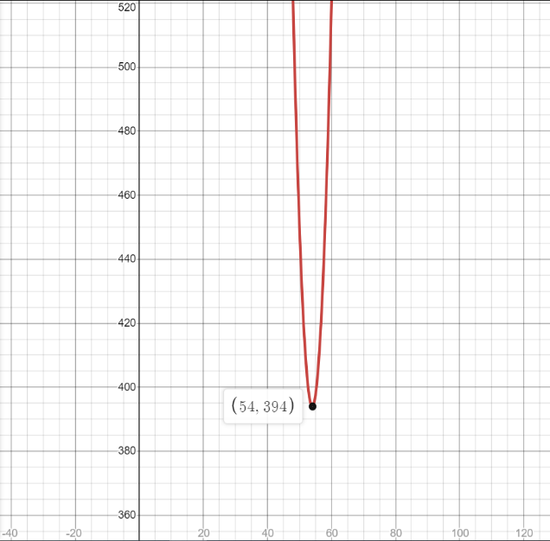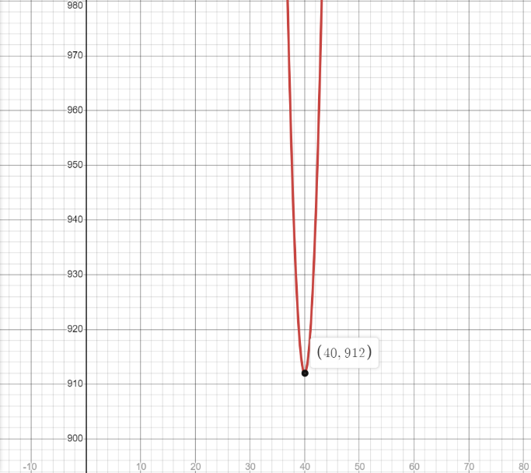Routine 1: Routine 2:

Based on the optimum points plotted on the graph, Routine 2 has a faster execution time and a larger input stream. Therefore, Routine 2 should be selected and the size of the input stream should be 54 records.